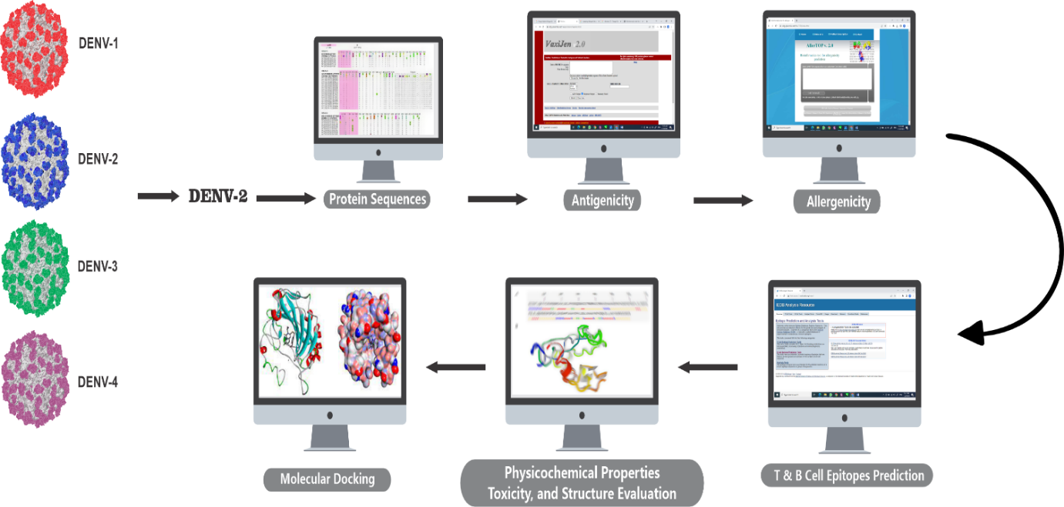
Graphical Abstract: Multi Epitope-Based Vaccine Designing of Dengue virus-2 Enveloped Protein for Dengue Virus using In silico approach

